The DOM also defines a specialized object called a NodeList that represents a collection of nodes. It operates very similarly to an array (e.g., you use numeric indexes within square brackets), even though it doesn’t have all array methods and properties because NodeList and Array inherit from different prototypes (you will learn about prototypes in the next chapter).

9.1.1 Nodes and NodeLists Text node
In the DOM, each element within the HTML document is called a node. If the DOM is a tree, then each node is an individual branch. As can be seen in Figure 9.2, there are element nodes and text nodes (plus a few other uncommonly encountered ones).

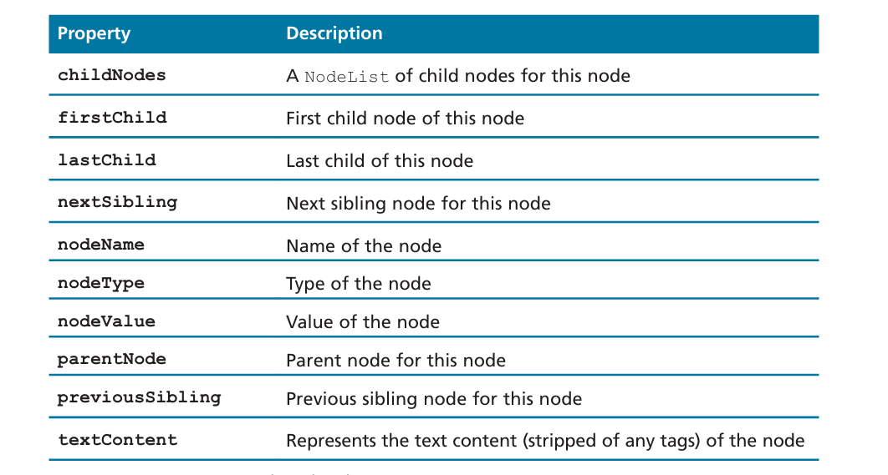

// retrieve the URL of the current page
let a = document.URL;
// retrieve the page encoding, for example ISO-8859-1
let b = document["inputEncoding"];

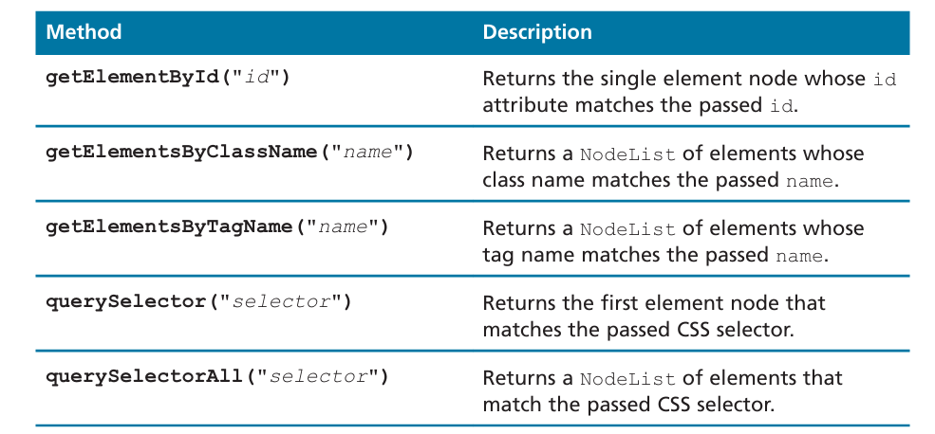
Selector Methods

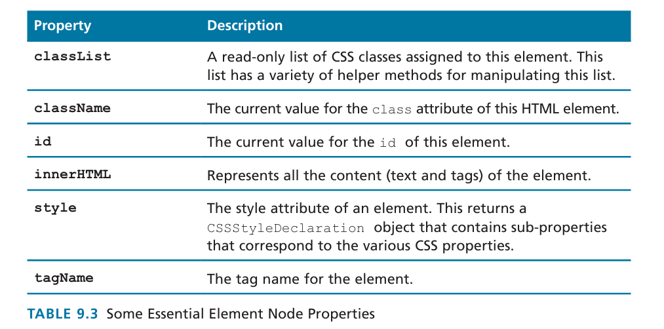

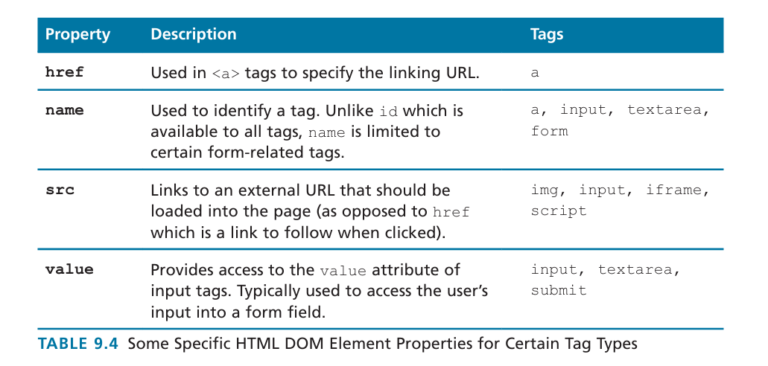

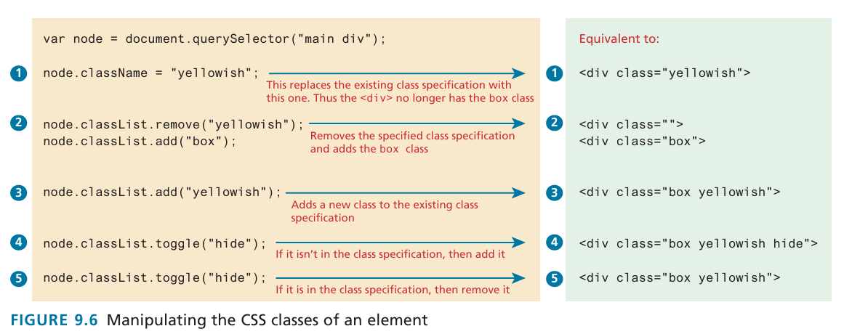

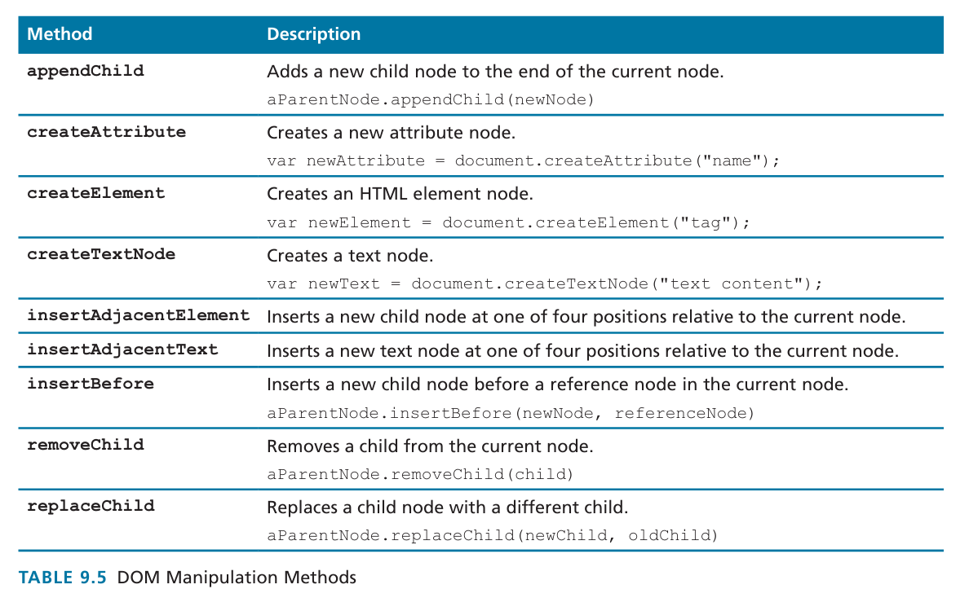

Done till dom timing

